Low Level Design (Registration module)

Project Code | Team2
Project Name | Online Recruitment Management System

Prepared/Modified by | Role | Date of Preparation
Akash Bansal | Senior Software Analyst | 11/11/2017
Reviewed by | Role | Date of Review
Vaishali Srivastava | Consultant | 16/11/2017
Approved by | Role | Date of Approval
Vishal Mali | Senior Consultant
Circulation List | akash.bansal@capgemini.com,  mvallamk@capgemini.com,  kaustav.saha@capgemini.com,  mohit.deshmukh@capgemini.com | Version Number of the template:1.0
Version Number | 1.3

Table of Contents

1. Description Of The Unit 3
2. References 4
3. Dependencies / Assumptions 5
4. Class Diagrams 6
5. Sequence Diagrams 7
6. Design Components 8
6.1 List Of UI Components 8
6.2 List Of Design Classes 8
7. Re-Usable Routines/Components 9
8. Messages 10
9. Configuration Files 11
10. Crud Matrix Table 12
11. Data Mapping Matrix 13
12. Action Flow Matrix 14
13. Stored Procedures 15
14. Program Specification / Pseudo Code 16
REVISION HISTORY OF THE WORK PRODUCT 17

Description Of The Unit

The Registration module allows the Visitor to register on the portal. He/she can choose their type (User,Company,Admin) and enter the registeration details.

If the entered credentials are valid he/she is directed to Login Page else he/she will stay on signup page only.

References

Reference | Description
Repository reference | https://IGTEBLRSVNTNG.igatecorp.com/svn/oct3_Team1
Class Diagram | /Project Documents/Design Documents/HLD/Class Diagrams
URS | /Project Documents/Requirements/Case Study/Ecommerce-grp1 and grp3.doc
UTP | /Project Documents/Test Plan/UTP/Test Cases/Registration Module
DB Design | /Project Documents/Design Documents/HLD/DB Design/E-Commerce_GROUP_DBDESIGN.xls

Dependencies / Assumptions

Assumptions:
The details of the user are stored in the database.

Class Diagrams

Class Diagram

Sequence Diagrams

Sequence Diagram
N/A

Design Components

List Of UI Components

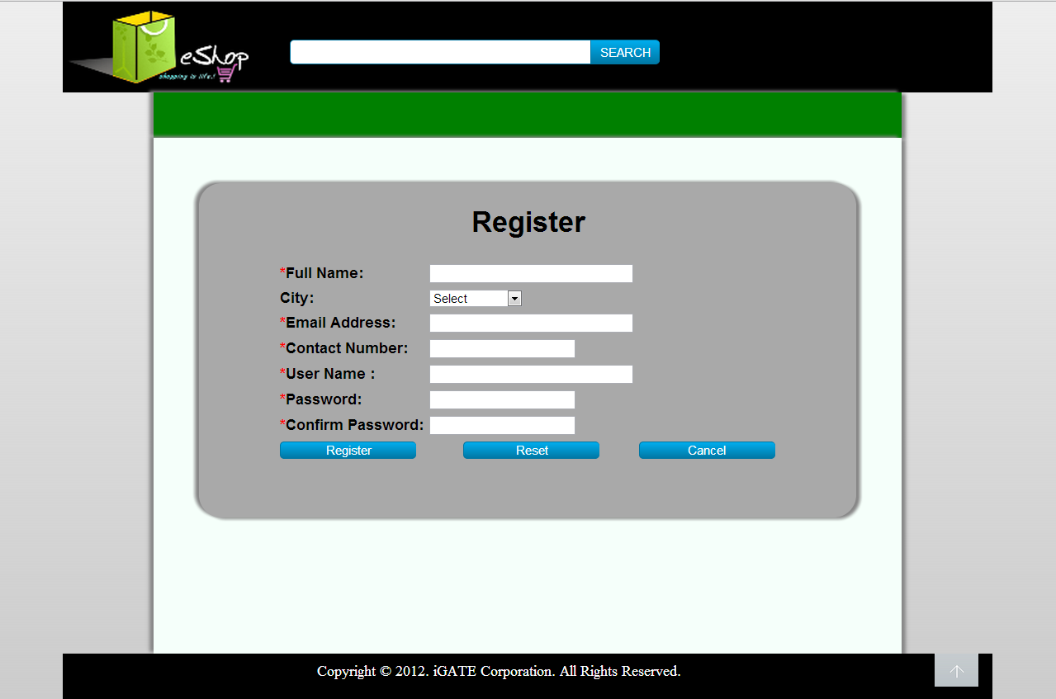

List Of Design Classes

Sr. No. | LLD Name | Class Name | Method Name | Method Description
1 | Registration Module | Login | Appropriate getters and setters methods | Getters retrieve the property values and setters set the property values
2 | Registration Module | RecruitmentController | showSignupPage(Model model):String  signup(@ModelAttribute  (“login”)@Valid Login login, ,BindingResult result ,Model model):String | Sets the model attribute.  Calls signUp() of RecruitmentServiceImpl class which in turn calls signUp() of RecruitmentDAOImpl and the details of  visitor are entered into the database.
3 | Registration  Module | RecruitmentServiceImpl | signUp(Login login):void | Calls signUp() of RecruitmentDAOImpl and returns the result to RecruitmentController.
4 | Registration  Module | RecruitmentDAOImpl | signUp(Login login):void | Adds the details to the database.

Re-Usable Routines/Components

Re-Usable Routines/Components

- CSS files
- DataAccessException class
- Database xml files
- Logger properties files

Messages

#. | Type | Message Text
M1. | Error | Please Select any option
M2 | Error | Only char and numbers are allowed
M3 | Error | Username can only be 8-16 characters long
M4 | Error | Password can only be 8-16 characters long
M5 | Error | Password must contain at least one character, one number and one special character. It must not start with a special character

Configuration Files

File Name | Path | Description
jpaContext.xml | /Development/Source/OnlineRecruitmentSystem/resources | To configure database connection.
web.xml | /Development/Source/OnlineRecruitmentSystem/WebContent/WEB-INF | To configure the bean properties and request mapping.
servlet-config.xml | /Development/Source/OnlineRecruitmentSystem/WebContent/WEB-INF/config | To configure view resolver.
log4j.properties | /Development/Source/OnlineRecruitmentSystem/resources | To configure the logger.
Eshop_error.properties | /Development/Source | To configure error messages.

Crud Matrix Table

# | Table Name | Create | Read | Update | Delete
1 | Login | Y | N | N | N

Data Mapping Matrix

Sr. No. | Screen Label | Field Source | Field Type | Data Type | Max Length | Data Flow | Mandatory
1 | Signup as | NA | Label | NA | NA | UI | NA
2 | optType | Login.type | Radio | Varchar2 | NA | UI → D | Yes
3 | UserName | NA | Label | NA | NA | UI | NA
4 | txtUserName | Login.userName | TextBox | Varchar2 | 16 | UI → D | Yes
5 | Password | NA | Label | NA | NA | UI | NA
6 | txtPassword | Login.password | TextBox | Varchar2 | 16 | UI → D | Yes
7 | Login | NA | Button | NA | NA | UI | NA

Legend

UI (User Interface Only)
UI → D (User Interface to Database)
D → UI (Database to User Interface)

Action Flow Matrix

Sr. No. | Action | Description | Process
1 | On click of SignUp Button | Valid User details are stored in to the database. | Customer details are validated if valid details are added to database the customer is navigated to Login page, if not, he/she will stay on same page with error diaplyed.

Stored Procedures

# | Stored Procedure Name  (with Description) | Input/Out Parameters | Type | Size
1. | NA | NA | NA | NA

Program Specification / Pseudo Code

14. 1 <ACTION: ONPAGE_LOAD>

Pseudo Code:

- Client Side Scripting
None
- Server Side Scripting

BEGIN
Calls prepareRegister(Model model) in EshopController class.
Navigates to Register Page.
END

14. 2<ACTION: REGISTER_CLICK>

Pseudo Code

- Client Side Scripting:

IF Full Name Filed is Empty
Print Error Message M1
IF Full Name is Invalid
Print Error Message M2
IF User Name Filed is Empty
Print Error Message M3
IF User Name is Invalid
Print Error Message M4
IF User Name >10 characters
Print Error Message M5
IF Email Id Filed is Empty
Print Error Message M6
IF Email Id is Invalid
Print Error Message M7
IF Password Filed is Empty
Print Error Message M8
IF Password length is >16
Print Error Message M9
IF Confirm Password Filed is Empty
Print Error Message M10
IF Confirm Password not same as Password
Print Error Message M11
IF Contact Number Filed is Empty
Print Error Message M12
IF Contact Number is Invalid
Print Error Message M13
IF Contact Number length is >16
Print Error Message M14

- Server Side Scripting:
BEGIN
Call prepareRegister (Model model) in EshopController class in Presentation Layer
BEGIN
Call registerUser(Customer customer) in EshopBOImpl class in Service Layer
BEGIN
Call registerUser(Customer customer) in EshopDAOImpl class in Data Access Layer
BEGIN
Create query to insert data in to User and Customer table
Return integer indicating if inserted or not
END
The result of the query is stored in an integer variable.
END
Return integer value to Service Layer
END
Return integer value to EshopController
END
IF true navigate to Home Page
REVISION HISTORY OF THE WORK PRODUCT

# | Date | Version # | Section Changed | Details of changes made | Approved By
1 | 16/12/2013 | 1.0 | LLD prepared | N/A | Uma M Ponniamman
2 | 17/12/2013 | 1.1 | Reusable components,  Pseudo Code,  Data Mapping Matrix. | Reusable components added.  More specific control flow specific.  More rows were added specifying the buttons of the form. | Uma M Ponniamman
3 | 18/12/2013 | 1.2 | Reusable components,  References,  Data Mapping Matrix. | Reusable Components added.  File name with relative path is added in the references section.  The name of text boxes(screen label is changed). | Uma M Ponniamman
4 | 20/12/2013 | 1.3 | Messages | Changes made in Error Messages. | Uma M Ponniamman
5 | 24/12/2013 | 1.4 | Configuration files,UI Components | Paths of the configuration files is updated and UI components(Screen Shots) added. | Uma M Ponniamman

